**Experiment No. 3**

Aim: To implement OLAP operations: Slice, Dice, Rollup, Drilldown and Pivot.

Requirements: Windows/MAC/Linux O.S and MYSQL/Oracle SQL.

Problem statement: To implement OLAP operations: Slice, Dice, Rollup, Drilldown and Pivot on Electronic sales data set created in experiment 2.

Theory:

**Online Analytical Processing (OLAP)** is a category of software that allows users to analyse information from multiple database systems at the same time. It is a technology that enables analysts to extract and view business data from different points of view.

Analysts frequently need to group, aggregate and join data. These OLAP operations in data mining are resource intensive. With OLAP data can be pre-calculated and pre-aggregated, making analysis faster.

**OLAP cube:**

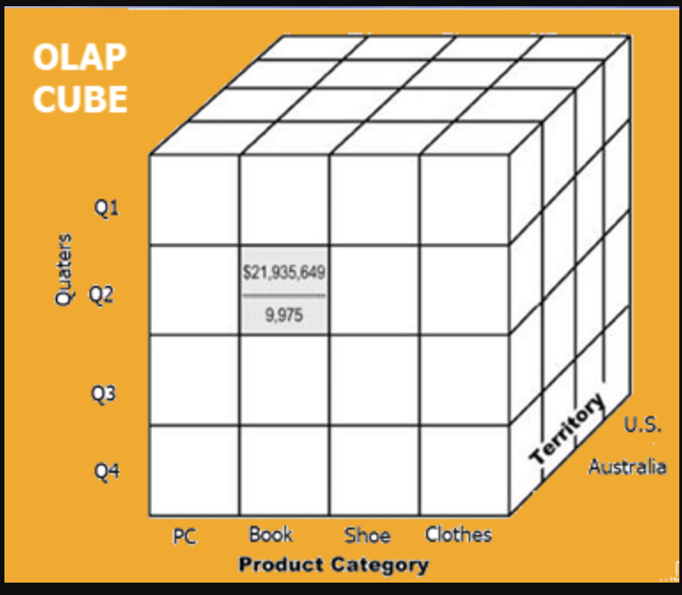

OLAP Cube

At the core of the OLAP concept, is an OLAP Cube. The OLAP cube is a data structure optimized for very quick data analysis.

The OLAP Cube consists of numeric facts called measures which are categorized by dimensions. OLAP Cube is also called the **hypercube**.

**Basic analytical operations of OLAP**

Four types of analytical OLAP operations are:

1. Roll-up
2. Drill-down
3. Slice and dice
4. Pivot (rotate)

**1) Roll-up:**

Roll-up is also known as “consolidation” or “aggregation.” The Roll-up operation can be performed in 2 ways

1. Reducing dimensions
2. Climbing up concept hierarchy. Concept hierarchy is a system of grouping things based on their order or level.

Roll-up on factsales, product_dw and time_dw:

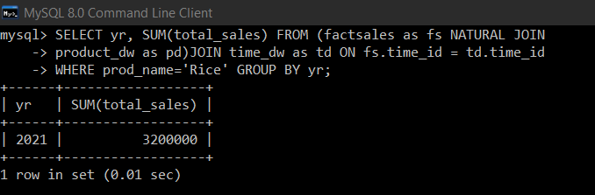

**2) Drill-down**

In drill-down data is fragmented into smaller parts. It is the opposite of the rollup process. It can be done via

* Moving down the concept hierarchy
* Increasing a dimension

Drill-down on factsales, product_dw and time_dw:

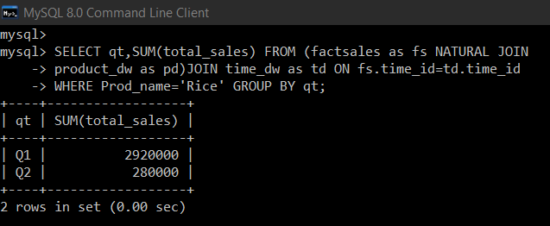

**3) Slice:**

Here, one dimension is selected, and a new sub-cube is created.

Slice on factsales, product_dw and time_dw:

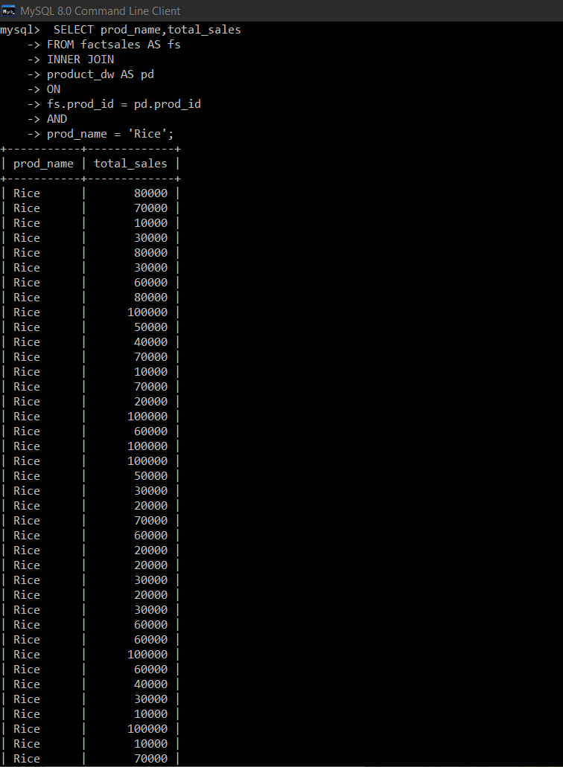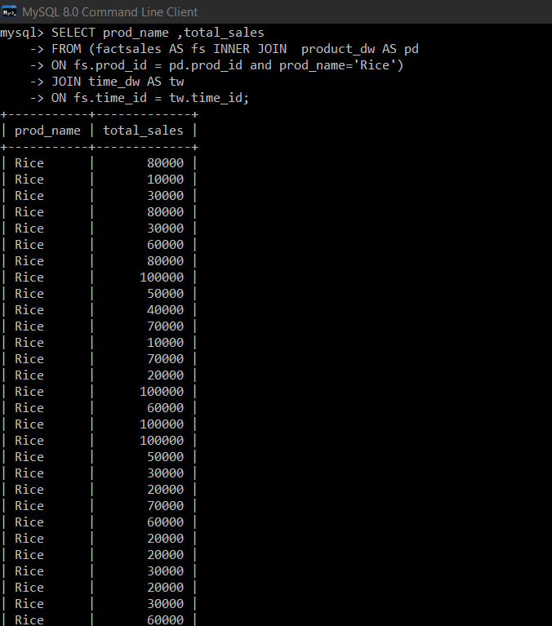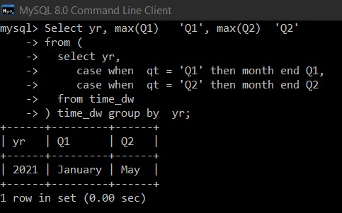

**4) Pivot**

In Pivot, you rotate the data axes to provide a substitute presentation of data.

Pivot on time_dw:

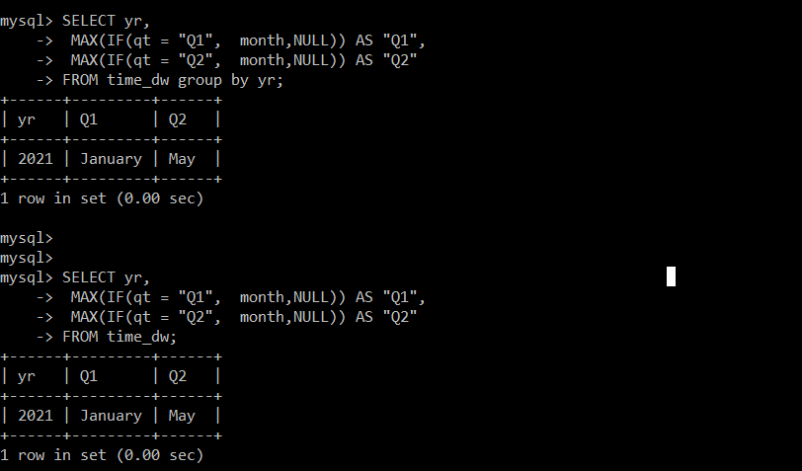

Conclusion: We have successfully implemented OLAP operations on Electronic sales data set using MYSQL.